**Open Source Development Lab**

Music Player in Python

By – 14bce022, 14bce030

**Abstract-**

This is a music developed in perl. For now this simple version can play any song of your choice. You can pause, resume and play any other song while one song is being played.

**Flow Diagram** -

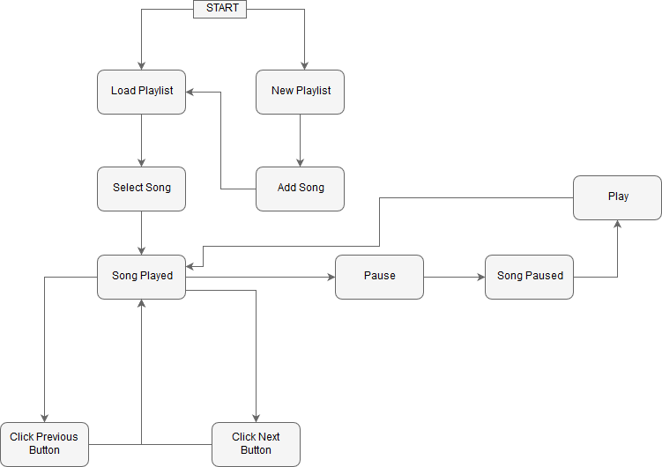

**Features of Python Used -**

**Perl Tk** – The Perl/Tk module, also known as pTk or ptk, is a Perl module designed to create widgets and other commonly used graphical objects to form a graphical user interface (GUI). Using the module to create a GUI enhances the look and feel of a program and helps the end user navigate through the program and its functions. One major advantage of using the Perl/Tk module is that the resulting application can be cross-platform, meaning the same GUI application can be used on UNIX, Linux, Macintosh, Microsoft Windows, or any other operating system that has Perl and the Perl/Tk module installed.

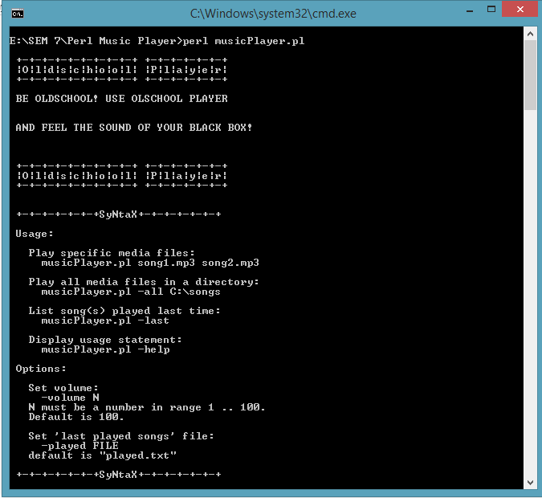

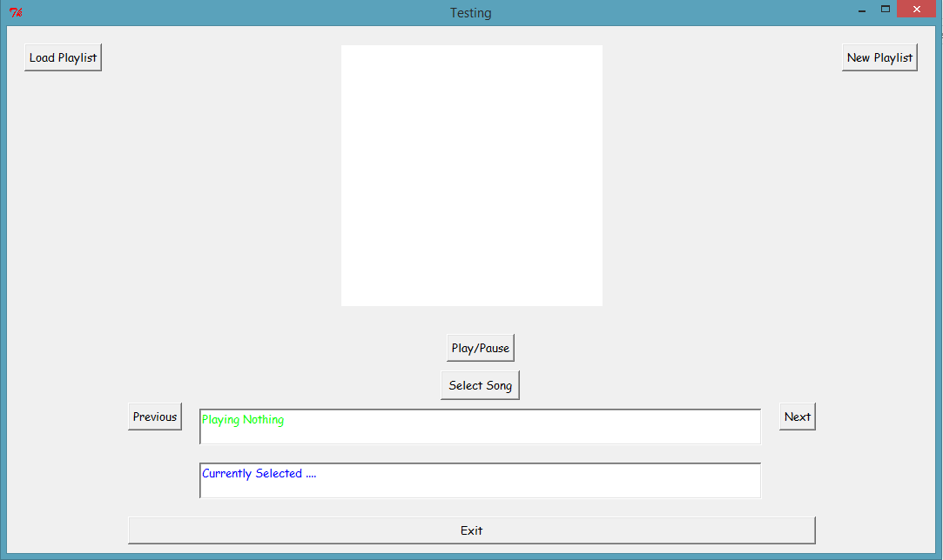

**Perl GetOpt Module -** The Getopt::Long module implements an extended getopt function called GetOptions(). It parses the command line from @ARGV, recognizing and removing specified options and their possible values.

This function adheres to the POSIX syntax for command line options, with GNU extensions. In general, this means that options have long names instead of single letters, and are introduced with a double dash "--". Support for bundling of command line options, as was the case with the more traditional single-letter approach, is provided but not enabled by default.

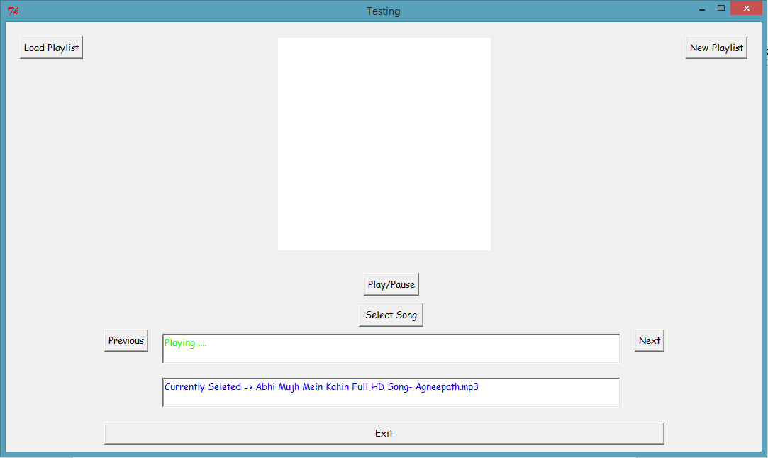

**Limitations -**

* The application only allows users to play music and does not give themm any other options.
* There is no functionality for creating and loading playlist.
* There is no functionality jumping to some other point in music.

**Conclusion -**

The application is developed to get introduction to perl GUI programming. The application developed is limited in many ways but at the same time can be used by a wide variety of users for fun. The application can be enhanced by adding playlist functionality and allowing user to jump to any part of the music.